University Of Engineering and Technology, Lahore
Computer Engineering Department

Course Name: Programming Fundamentals | Course Code: CMPE-112L
Assignment Type: Lab Tasks | Dated: 7 June 2026
Semester: First | Session: 2026 Spring
Lab/Project/Assignment #: 1 | CLOs to be covered: CLO 3
Lab Title: GUI using Qt Designer | Teacher Name: Hafiz Muhammad Mubashar
Lab Evaluation:

CLO3 | Apply appropriate programming techniques to create executable programs to solve well defined problems
CLO3 | Level1 | Level2 | Level3 | Level4 | Level5 | Level6
(5)
Total |  |  |  |  |  | /5
Rubrics for Current Lab Evaluation
Scale | Marks | Level | Rubric
Excellent | 5 | L1 | Submitted all lab tasks, BONUS task, have good understanding.
Very Good | 4 | L2 | Submitted the lab tasks but have good understanding
Good | 3 | L3 | Submitted the lab tasks but have weak understanding.
Basic | 2 | L4 | Submitted the lab tasks but have no understanding.
Barely Acceptable | 1 | L5 | Submitted only one lab task.
Not Acceptable | 0 | L6 | Did not attempt
Week 15 LAB
GUI using Qt Designer
Lab Goals/Objectives:
• To understand and design Graphical User Interfaces (GUIs) using Qt Designer (.ui layout XMLs).
• To master structural widget organization using layouts (QVBoxLayout, QHBoxLayout) and custom container spacing.
• To design intuitive multi-role workflows involving separate authentication screens, input entry forms, data visualizers, and administrative tables.
Equipment Required:
* Computer/Laptop
* Python 3.14
* VS Code or pycharm

Theory:
Qt Designer is a visual layout tool used to design cross-platform user interfaces. The resulting .ui file is a structured XML document describing widget hierarchies, geometries, and visual styles.

Lab Work:

Task 1: Institutional Portal Interface (UET login Page.ui)

• Core Components: Dark contrast wrapper background (rgb(54, 54, 54)), explicit single-line credential forms (QLineEdit), rounded edges (border-radius:15px), and an institutional banner label.
• Design Focus: Simple, absolute coordinate layouts emphasizing clean readability and basic entry constraints.

Result:

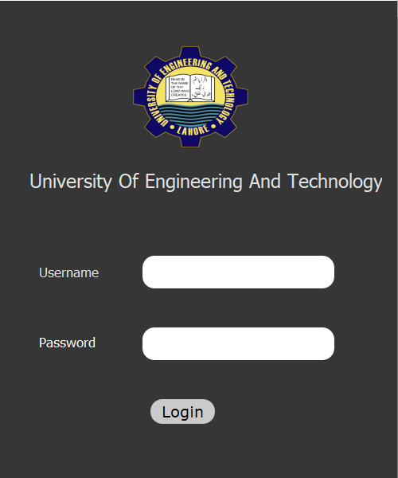
Task 2: Multi-Role Patient Authentication (login.ui)
• Core Components: Custom linear gradients (stop:0 #e0f7f4, stop:1 #b2dfdb), centered multi-input card alignment fields, and a distinct alternate login redirect option (doctorLoginButton).
• Design Focus: Aesthetic entry gates that cleanly segment user privileges right from the access layer.

Result:

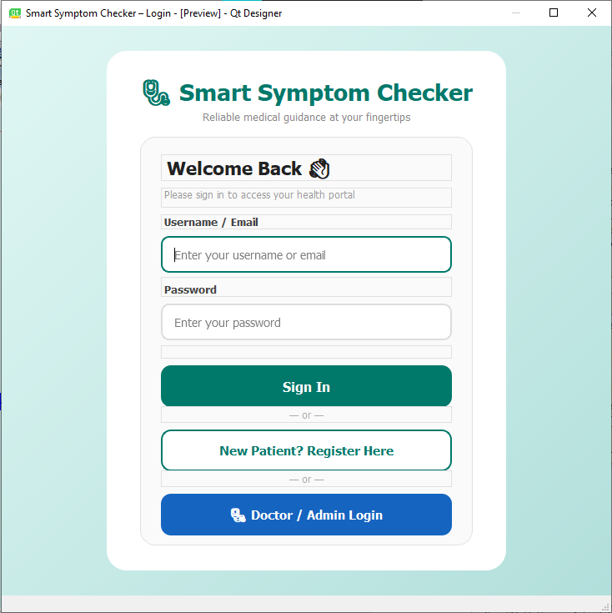

Task 3: Interactive Account Creation (register.ui)
• Core Components: Extended input submission layout fields, validation inputs, custom active submission blocks (registerButton with solid teal background #00796B), and a login fallback route button.
• Design Focus: Complete input validation structures ensuring smooth user registration pipelines.
Result:
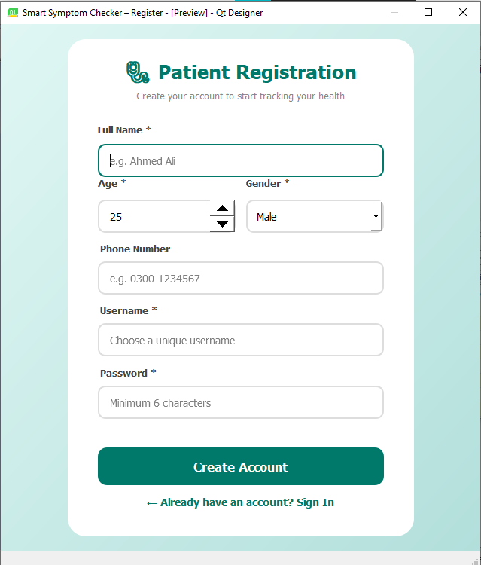

Task 4: Privileged Access Entry Portal (doctor_login.ui)
- Core Components: Secure credential masking text boxes, high-visibility interactive signature buttons (🩺 Doctor Sign In utilizing rich hovering effects), and standard back-navigation triggers.
- Design Focus: Dedicated secondary authentication screen designed for secure clinical administrator sessions.
Result:
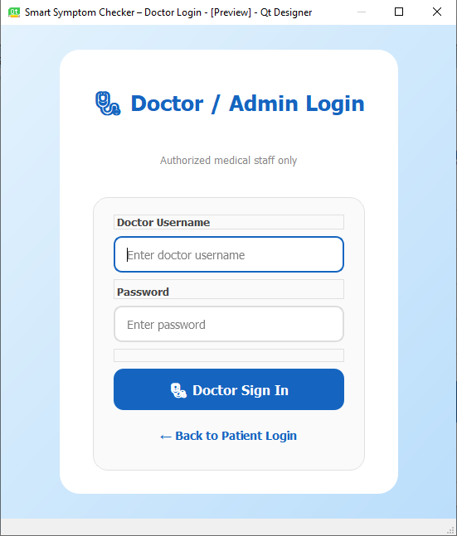

Task 5: Clinical Operation Hub (doctor_dashboard.ui)
• Core Components: Multi-column historical tracking layout table (QTableWidget), alternating color row parameters, and dynamic status labels (emptyLabel) to handle blank results elegantly.
• Design Focus: Creating a high-density, analytical data control deck tailored for medical practitioners.
Result:
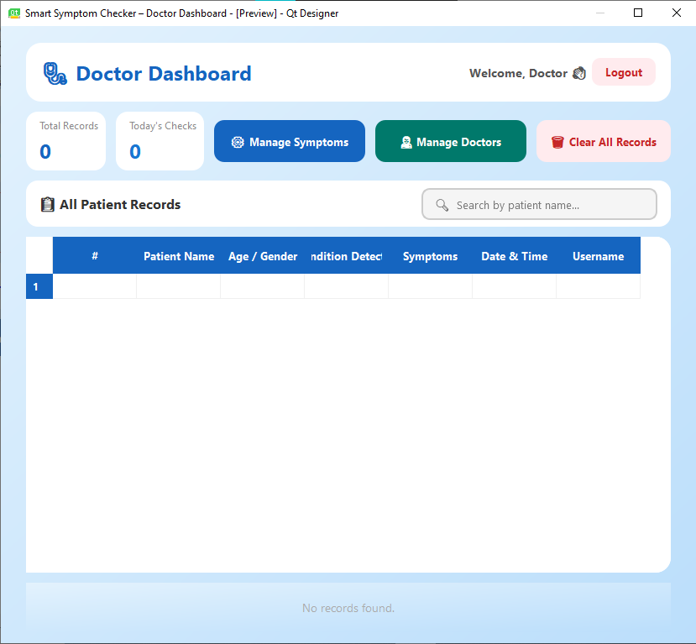

Task 6: Directory Management System (manage_doctors.ui)
- Core Components: Database row interaction controls, custom modifying triggers (editDocButton), explicit deletion actions (deleteDocButton with distinct caution-red styling #c62828), and spacer configurations.
- Design Focus: Standard CRUD (Create, Read, Update, Delete) administrative control flows.
Result:
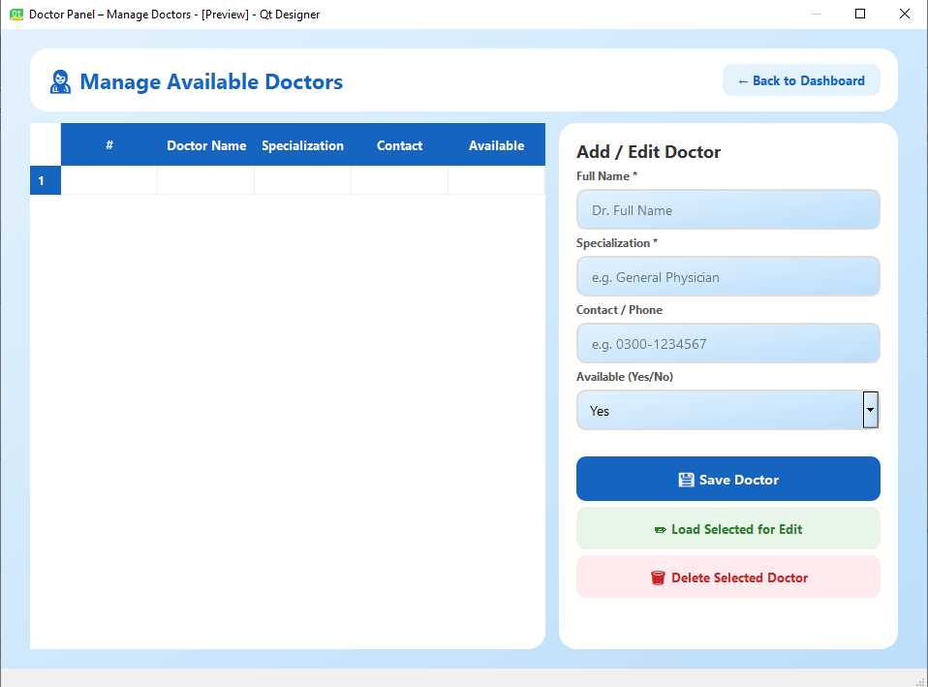

Task 7: Dynamic Parameter Customization Interface (manage_symptoms.ui)
- Core Components: Custom inline addition handlers (addSymptomButton), input mapping grids, and informative hint containers styled for persistent user documentation.
- Design Focus: Allowing system administrators to safely modify variables that directly alter front-end user experiences.
Result:
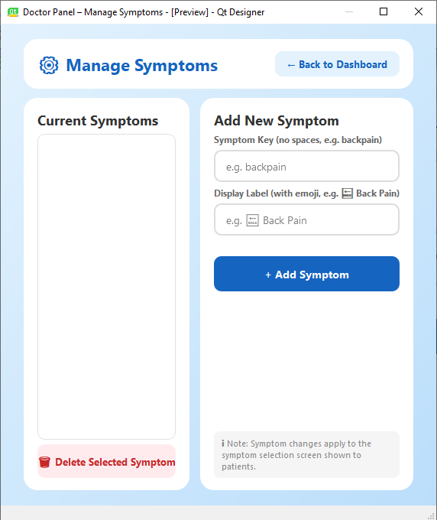

Task 8: Medical Feature Selection Questionnaire (symptoms.ui)
- Core Components: Large element layout arrangements, multiple selection choice boxes, reset state triggers (clearButton), and distinct action execution prompts (Predict Disease →).
- Design Focus: Optimizing multi-input check patterns to gather clinical parameters comfortably.
Result:
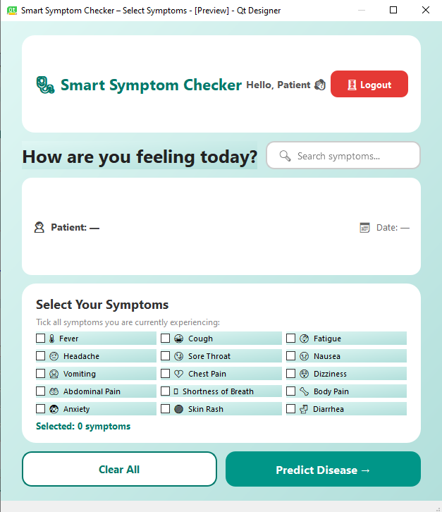

Task 9: Diagnostic Evaluation Feedback Screen (results.ui)
- Core Components: Informational panel layouts (infoCard4), styled bullet labels (warningLabel colored in amber #fff8e1), and prominent condition results displays.
- Design Focus: Presenting hierarchical information effectively by keeping classification outputs separate from general notes.
Result:
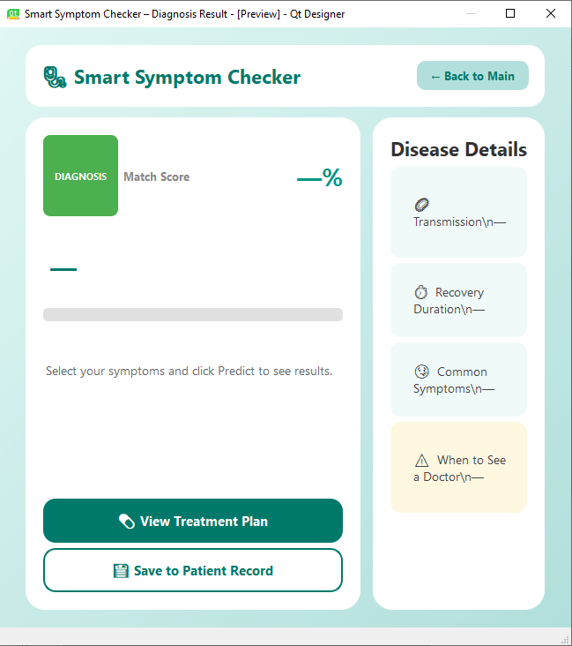

Task 10: Complete Patient History Log (records.ui)
- Core Components: Wide tabular arrays (QTableWidget) detailing timestamps, demographics, and symptom outputs alongside automated placeholder reminders.
- Design Focus: Full log aggregation ensuring seamless navigation through archived data assets.
Result:
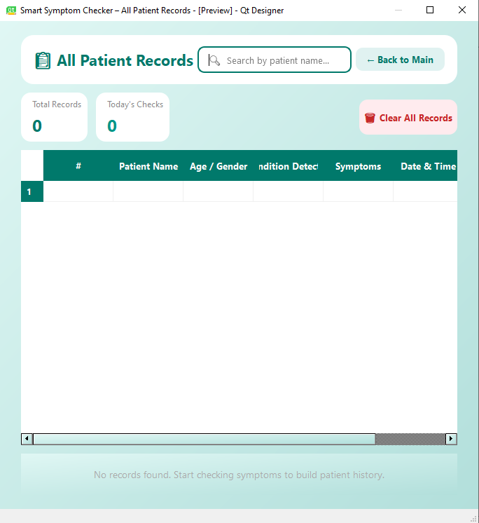

Task 11: Clinical Recovery Plan Screen (treatment.ui)
- Core Components: Main description display fields (treatmentBox), safety disclaimer containers (warningBoxText), standalone warning text fields, and a prominent loop-back trigger button (checkAgainButton).
- Design Focus: Providing clean, separate sections for final therapeutic feedback while ensuring the user can easily find the button to restart the questionnaire workflow safely.
Results:
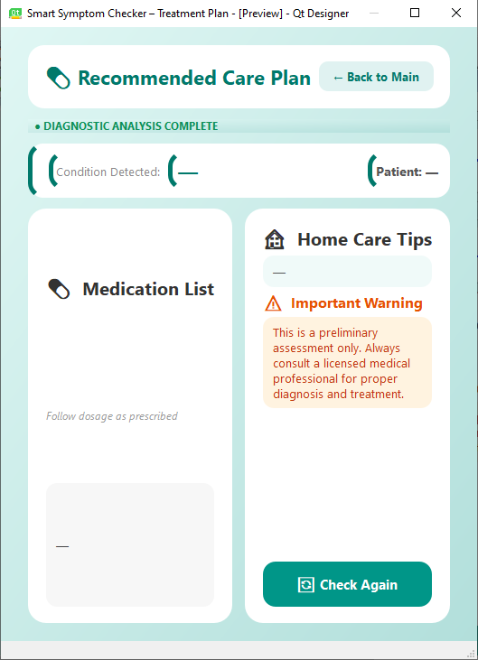

Conclusions:
This lab successfully demonstrates how Qt XML layouts standardize front-end designs for desktop applications. By mapping distinct interfaces—ranging from entry portals to complex data tables—we established how structured styling sheets, vertical/horizontal layouts, and clean widget hierarchies combine to form modern, adaptive, and highly functional user systems.

